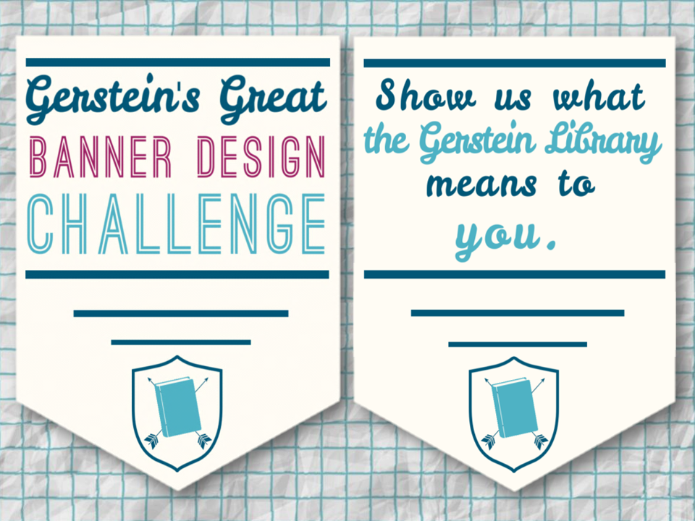
Banner Design Submission Form

Please submit this form along with your design file as attachments to: contest.gerstein@utoronto.ca

- All submissions are due by 11:59 pm EST on September 19, 2014 -

Name(s): | E-mail Address: | Phone #: | UTORid:
1)
2)
3)
4)

Title of Banner Design:

Briefly describe the theme(s) reflected in your design (50 word maximum):

By checking these boxes:

- You verify that the design you are submitting was created by you as an original work and does not contain content for which someone else owns the copyright, including photographs and images, created by others which you do not have authorization to use.

- You verify that written permission has been obtained from each individual who appears in the design and can be made available upon request. Please use the linked form to obtain permission from all individuals appearing in the design.

- You give the University of Toronto Libraries (UTL) permission to use your name(s) and design in UTL promotional materials, including the UTL website. All intellectual property rights remain with the creator of the design. UTL reserves the right to use the design in its entirety, partially, or adapt at our discretion.

- You give UTL permission to contact you at a later date to complete a survey about your participation in this contest.

University of Toronto Libraries Privacy Policy:

The University of Toronto Libraries values and respects the right to privacy and confidentiality of the information which is shared and collected by us. User information collected is kept private and confidential. No information gathered, collected or shared will be given, sold or distributed to any entity outside the University of Toronto.

For questions about this form or the contest, please contact contest.gerstein@utoronto.ca.

